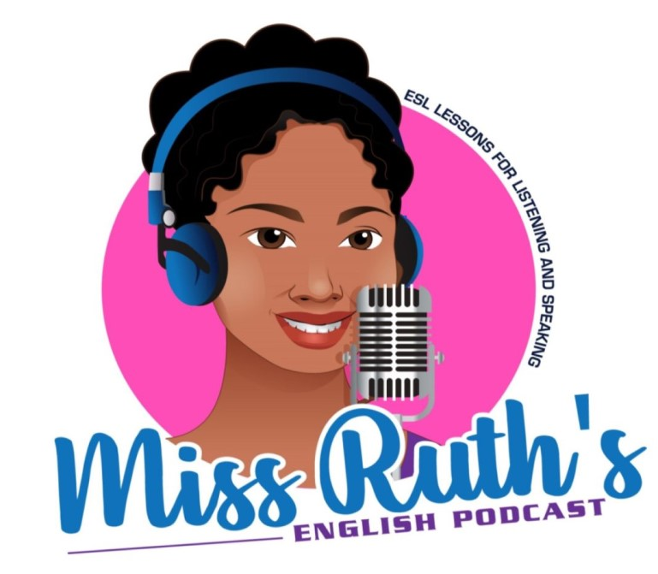
Week 1: Common Phrases for Routines, Phone Conversations & Home

Routines

In the Morning

- I wake up at 6 am.
- I drink a cup of coffee/tea.
- I take a taxi/an Uber/the bus/the subway/the tram.
- I press the snooze button twice before I turn my alarm off.
- I read the newspaper.
- My mom/dad/husband/wife gives me a ride to work/school.
- I get up around 6:30 am.
- I check my social media.
- I answer my emails.I make my bed.I check my emails.
- I attend meetings.
- I take a shower.
- I walk my dog.
- I have a snack around 10 am.
- I get dressed.
- I go to the gym.
- I have lunch at home/at the cafeteria/on the go.
- I do my hair and makeup.
- I go to work/school.
- I go home and make lunch.
- I brush my teeth.
- I work from home.
- I wash/do the dishes.
- I make breakfast.
- I wait for the bus.
- I put the dishes away.
- I eat/have breakfast.
- I drive to work/school.
- I take a nap after lunch.

In the Evening

- I buy groceries after work.
- I brush my teeth.
- I take off my makeup.
- I get home from work/college/school at 5 pm.
- I put on my pajamas.
- I set the alarm clock.
- I clean up the house.
- I plan the next day.
- I charge my phone.
- I make dinner.
- I check the weather.
- I put my phone away.
- I order dinner.
- I watch Netflix.
- I meditate.
- I take out the trash after dinner.
- I listen to music.
- I turn off the lights.
- I feed my dog/cat.
- I read a book before bed.
- I go to bed.
- I take my medication.
- I lock the doors.
- I fall asleep.
- I take a warm bath.
- I tuck my kids in.
- I sleepwalk.

From PrepEng
Phone Conversations

Answering the phone
- Good morning/ afternoon/ evening. ABC Limited. Alex Case speaking. How can I help you?

Saying who you are (caller)
- My name is Francis Cripps. I work for JUPG PLC.
- This is Francis Cripps (again), (calling) from JUPG PLC.
- Hi Alex. It’s Francis Cripps (from Finance/…) (again).

Small talk
- How’s it/ the conference/ your week/ your project/… going?
- Did you have a good weekend/ trip/ holiday/…?
- How’s business?
- I heard that the weather there is much cooler/ that…
- I guess that you are really busy/ that…
- I’m (so) glad/ sorry/ happy/ relieved/ … to hear that.
- (That) sounds great/ terrible/ awful/ interesting/ nice/ encouraging/ fun/ …
- How about you?

Being polite
- Thanks for calling me back.
- Thanks for getting back to me (so quickly).
- Sorry to phone so early in the morning (but…)
- Sorry it took me so long to get back to you.
- Sorry to ring again so soon (but…)
- Sorry to trouble you again (but…)

Ending the small talk/ Smoothly getting down to business/ Moving towards the topic
- So, what can I do for you today?
- Anyway, have you got a minute (to talk)?

Talking about the reason for the phone call
- I just got your message.
- I’m returning your call.
- Someone phoned me from this number.
- Anyway, I’m phoning about the meeting next week/ about…
- I’m calling to ask about the meeting next week/ to…
- So, did you see my email about the delivery/ about…?
- Well, just a quick call to say…
- Well, I was given your number by…
- I found your number…

Asking to speak to someone
- Can I speak to Kim Smith (in the Sales Department), please?
- Is Kim (Smith) there?
- I’d like to speak to someone about replacing our photocopiers/ about…
- I need to speak to someone in the shipping department/ in…

Asking about the caller’s name
- Sorry, I didn’t catch your name.
- May I ask who is calling?

Asking about the receiver
- Sorry, who am I speaking to, please?
- Is that Kim (Smith)?
- Is this the right number for the HR department/ for…?
- Is that the… department/ division/ section/ team?
- Are you the right person to speak to about…?

Connecting the caller to the right person
- Can I ask what it is concerning?
- Of course. I’ll (just) check if he’s available.
- Okay. I’m putting you through.
- I’ll connect you to… She should be able to help.

Negative answers to requests to speak to someone
- I’m sorry but she’s away from her desk/ out of the office/ out of the country/ not in today. (She should be back…)
- I’m afraid he’s on another line/ her line is busy/….

Leaving messages/ Dictating
- Can I leave a message?
- Can you tell her that…?
- Can you ask her to send me six hundred and fifty HYDV765s/ to…?
- My office number/ work number/ landline/ mobile (number)/ home phone is oh one double six treble one.
- My (postal) address is twenty three black new word bird park new line midtown capital b capital b capital p capital m.
- The URL is http colon double slash high dash life dot com slash alex underscore case.
- My (work/ personal) (e)mail address is alexcase all one word at outlook dot com.

Taking messages/ Taking dictation
- Does she have your number?
- Can I take a message?
- Shall I ask her to call you back?
- (Okay.) Got it (now) (,thanks).

Other responses to someone not being there
- No, that’s okay, thanks. I’ll (just) call again later. (Do you know when she will be available?)
- Actually, it’s quite urgent. Could you give me his mobile number?
- Is there anyone else I can speak to about…?
- Can I help you at all?

Asking people to wait
- Please hold the line. I’ll connect you to a member of our customer service staff/ I’ll check if she’s available/ I’ll…
- Just a moment while I get a pen and some paper/ while I find the file/ while I…. Okay, please go ahead.
- Just a minute. I’m (just) getting your account up on the screen/ I’m (just)…

Checking/ Clarifying/ Not understanding/ Dealing with communication problems
- Can I check that back?
- Sorry, could you say that again (a little more slowly)?
- Sorry, can you repeat the first word/ the last part/…?
- … Is that right?
- Sorry, could you spell your family name/… (for me), please?
- Just to (double) check,…
- Sorry, is that B for Bobby (or V for virgin)/ one five (or five oh)/ two words (or all one word)/ …. (or…)?
- “There’s a lot of background noise – I can barely hear you.”
- “You’re breaking up. Could you call me back?”
(breaking up = you can only hear parts of what the other person is saying)
- “We have a bad connection.”
- “Sorry – I didn’t catch what you just said.”
- “Could you speak a little louder?”
(say this if the person is speaking too quietly)
- “Could you speak a little more slowly?”
(say this if the person is speaking too fast)
- “What did you say?” (informal)
- “Could you repeat that?” / “Could you say that again?” (more formal)
- Would you mind spelling that for me?
- Would you mind slowing down?
- Would you mind speaking a little more slowly?

Talking about written sources (documents, webpages etc)
- Do you have the information in front of you now?
- I’m sending you the document/ … right now.
- If you turn to page (number) three and look at the second paragraph,…

Ending taking messages
- Okay, I’ll make sure (that) he gets your message. (I’m sure he will get back to you soon.)

Checking that the other person has finished and responding to that
- So, is there anything else (that I can help you with) (today)?
- (Okay then,) was there anything else (that you’d like to ask)?
- No, that’s all (for now), thanks.
- Actually, there is just one more thing….

Smoothly ending a phone call (giving reasons for finishing the call, etc)
- Anyway, it’s been great to talk, but I’m afraid I have a meeting in a few minutes/ I’m afraid I… (so…)
- I’d like to talk more about this but I’m afraid someone has just come in/ I’m afraid… (so…)
- That seems to have covered everything, thanks.
- That’s been really helpful, thanks.
- Okay, I won’t keep you any longer, then.

Talking about the next contact between you/ Talking about the future
- Can I call you back (a little) later?
- Could you possibly call again (a little) later?
- I’ll email you by the end of business today/ later (today)/ in the next couple of days/…
- (I can’t hear you very well). Shall we hang up and try again?
- I’ll check (…) and call you (right) back.
- Could you (possibly) find out and call me back?
- Please call again if you have any other questions/ problems/...
- I look forward to your call.
- Looking forward to hearing from you.
- Speak to you then/ tomorrow/ soon/ later/… (, then).
- See you then/ tomorrow/ soon/ on Monday/ there/… (, then).

Polite and/ or friendly language at the end of the call
- Thanks for (all) your help.
- Thanks for calling/ your call.
- Sorry I couldn’t be more help.
- Have a good evening/ day/ weekend/….
- Bye (for now).

From Using English, Espresso English, and SpeakConfidentEnglish

