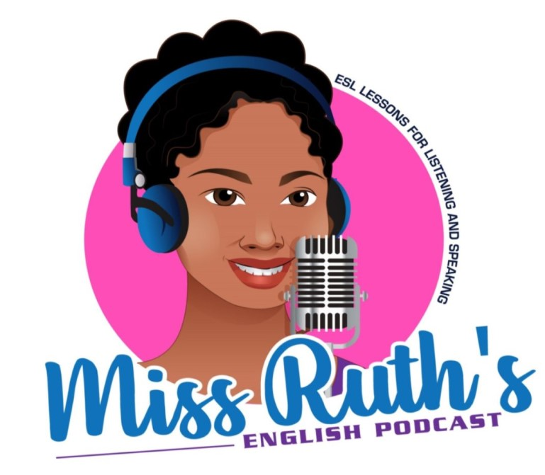
Week 3: Common Phrases for Food, Birthday & Movies

Movies

Movie Preferences
- What kinds of movies do you like?
- What genre of movies do you like?
- Do you like romantic comedies?
- Do you like horror movies?
- Are you into action movies?
- Are you a big comedy movie fan?
- Are you interested in documentaries about animals?
- Do you like to watch movies at home or at the movie theater?
- Who is your favorite actor?
- What is the best movie that you have ever seen?
- What is the best movie that you have seen recently?
Recommendations or about current movies.
- Are there any good movies out right now?
- Is there anything good showing at the theater today?
- Can you recommend a good horror movie for me?
- Do you know any good romantic movies?
- What action movie should I watch?
Talking about our own movie preferences.
- I like action movies.
- I enjoy documentaries and action movies, but I don't like romantic comedies.
- I like movies that have a good story. So, I like thrillers.
- I don't think that documentaries are very interesting. Actually, I think that they are boring.
- I'm into dark movies. They are more realistic.
- I like bloody movies, but my brother hates those kinds of movies.
- He is my favorite actor, so I like any movie that he is in.
Describing a movie
- It is too violent.
- It is very bloody.
- It was hilarious
- It was scary.
- It was terrifying.
- It was very romantic.
- It was too long.
- It is very interesting.
- It was boring.
- It was touching.
- It was moving.
- I think that it is the funniest movie I have seen in a long time.
- I thought that it was confusing.
- It is not appropriate for children.
- It is rated R.
- It is a fantastic movie.
- It is a great story.
- It is a sad movie.
- It had a lot of fight scenes.
- I couldn't stop laughing.
- I couldn't stop crying.
- It had many moving scenes.
- It was over 3 hours long.
- It was only an hour and a half.
- It was full of laughs.
- It had a lot of dirty jokes.
The actors and actresses
- Who is in it?
(=Who are the actors in the movie?)
- What is her role in the movie?
- How was she in the movie?
- Did she do a good job in the movie?
Other questions about the movie
- Where does the movie take place?
(=What is the setting of the movie?)
- When does the movie take place?
(=When does the story happen?)
- What is it about?
- What is the story about?
- Is it a true story?
- When does it come out?
- When will it be in theaters?
- What will the movie be released?
- Has it gotten good reviews?
- What are people saying about it?

Genres
- Action
- Animated
- Comedy
- Horror (gory)
- Documentary (biopic)
- Historical / Period Piece
- Horror
- Independent (Indie) films — movies that were not made by big, Hollywood studios or are more artistic in terms of theme and visuals
- Thriller — these movies are like horror movies, but they’re more “psychologically” scary
- Romantic comedy (sometimes referred to as “rom-com”)
- Science fiction or “sci-fi,” (with extraterrestrials or aliens or AI; can be apocalyptic or dystopia)

Adjectives

- Some synonyms for “bad” — awful, terrible, boring, predictable, overrated
- Some synonyms for “good” — great, well done, awesome, important, entertaining, informative
- Some synonyms to be neutral about a movie — alright, okay, so-so, not my favorite
- Award-winning — A movie that has won an award like an Oscar or a Golden Globe.
- Family-friendly — Films that are good for families to watch together (no explicit material).
- Critically-acclaimed — If you hear this, it means critics gave the movie good reviews.
- Visually-stunning — A movie that’s beautiful to watch.

From Talk English and Fluentu

Birthdays

Questions
- Do you enjoy birthdays?
- Do you usually celebrate your birthdays?
- What did you do on your last birthday?
- Can you remember a birthday that you enjoyed as a child?
- Do most people celebrate their birthdays with a party in your country?

Food

Common Questions
- How often do you eat out?
- What’s your favorite dessert? How often do you eat it?
- What’s the best place to eat in your town?
- Do you usually drink milk?
- What kind of meals do you like to eat?
- Do you like trying new foods?
- How many cups of coffee do you drink every day?
- Do you know how to cook?
- Can you cook very well?
- Do you eat bread every day?
- Do you eat fruits every day?
- What kinds of food did you eat when you were a child?
- How often do you eat out?
- Do you like chocolate? What is your favourite type?
- Do you like seafood?
- Do you like eating vegetables?
- What vegetables and fruits don’t you like?
- Do you like chocolate? What is your favourite type?
- Do you usually drink a beer when you eat?
- What is your favorite food? How often do you eat it?
- Are you a vegetarian? Why do some people stop eating meat?

Breakfast
- Do you usually drink coffee in the morning?
- Do you eat cereal in the morning?
- Do you usuually skip breakfast?
- What breakfast can you prepare?
- Do you make your own breakfast?
- What’s your favorite breakfast meal?

Lunch
- What time do you usually have lunch ?
- What do you usually have for lunch?
- Do you eat lunch at school?
- What lunch can you prepare?

Dinner
- What time do you usually have dinner?
- What do you usually have for dinner?
- Where do you usually eat dinner?
- What dinner can you prepare?

International Cuisine
- Do you like Italian food?
- Do you like Mexican Food?
- Do you like Chinese food?

Diet
- What’s a healthy diet?
- What do you usually eat to gain weight?
- What do you usually eat to lose weight?
- Have your intermitent Fasting?
- What do you think about diets?
- Do you usually think about nutrition when making meal choices?
- Do you think about the amount of calories you eat every day?
- How many calories do you eat per day?
- Do you track the amount of calories that you eat every day?

Fast Food
- What’s your favorite fast food restaurant?
- How often do you eat junk food?
- If you could, how often would you eat junk food?
- What ‘s your favorite fast food?
- Do you drink coke?
- How often do you drink sodas?
- What’s your favorite junk food?
- Do you like Hamburgers?
- Do you like Pizza?
- What’s your favorite pizza place?
- What’s your favorite pizza topping?
- Do you like unhealthy food?
- Do you like Tacos and Sandwiches?
- Which fast food restaurant serve healthy food?
- How often do you go to fast food restaurants
Adjectives

- salty
- spicy
- crunchy
- juicy
- ripe
- acidic
- naughty
- guilt-free
- cheat day
- addictive
- fattening
- cheat meal
- balanced
- delicious
- nourishing
- satisfying
- appetizing
- filling
- tasty
- fresh
- crunchy
- crisp
- mouth-watering
- yummy
- savour
- I’m stuffed
- wolf (it) down - eat a lot quickly
- pick at - eat a little, uninterested
- Work up an appetite - do something ot make you hungry
- spoils an appetite - do something that no longer makes you hungry
- could eat a horse - very hungry
- pig out - eat a lot excitedly

From EnglishPost and Dictionary Blog

