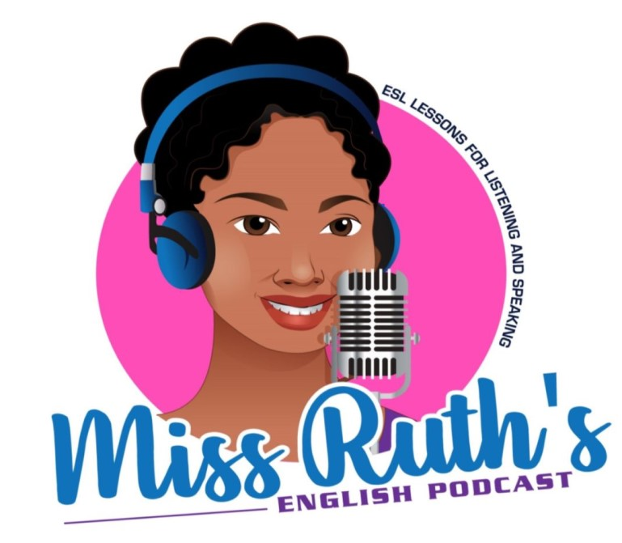
Week 4: Common Phrases for Families & Childhood

Families

Vocabulary
- Siblings
- Cousins
- Relatives
- Aunt
- Uncle
- Nephew
- Niece
- Grandparents
- Grandmother
- Grandfather
- Grandson
- Granddaughter
- Grandchildren
- Spouse
- Stepmother / Stepfather
- Stepson /stepdaughter
- Stepsister/stepbrother
- Half-sister
- Half-brother
- Sister-in-law
- Brother-in-law
- Father-in-law
- Mother-in-law

Brothers & Sisters
- Do you have any brothers or sisters?
  - Yes, I've got …
  - a brother
  - a sister
  - an elder brother
  - a younger sister
  - two brothers
  - two sisters
  - one brother and two sisters
  - No, I'm an only child
Children
- Have you got any kids?
  - Do you have any children?
  - Yes, I've got …
  - a boy and a girl
  - a young baby
  - three kids
  - I don't have any children
  - Do you have any grandchildren?
Parents & Childhood
- Where do your parents live?
- What do your parents do?
- What does your father do?
- What does your mother do?
- Are your grandparents still alive?
- Where do they live?

Idioms

the apple doesn’t fall far from the tree: The apple doesn’t fall far from the tree means that a child usually has similar qualities to their parents.
  - “It’s not unusual that you have the same interests as your mother. The apple doesn’t fall far from the tree.”

to follow in someone’s footsteps: To follow in someone’s footsteps means to try to achieve the same things that someone else (usually a family member) has already done.
  - “I decided to go into law instead of medicine. I thought about following in my father’s footsteps and becoming a surgeon, but I don’t think I’d make a great doctor.”
- like father, like son / like mother, like daughter: Like father, like son is an expression that means that sons tend to be similar to their fathers. We normally use this idiom to talk about personality, interests, and character.
  - “Jimmy is tall just like his father, and they have the same smile. Like father, like son.”
- to run in the family: If something runs in the family, it means that many members of the family have that quality, skill, interest, problem, disease, etc.
  - “Heart disease runs in my family. I try to have a healthy diet and get plenty of exercise.”

in one’s blood: If something is in one’s blood, it means that it is a fundamental part of who that person is and something that is ingrained in that person’s family.
  - “Law is in my blood. I’m a lawyer, and so is my father, my grandfather, and two of my aunts.”

spitting image: If someone is a spitting image of another family member, it means that those two people look almost identical.”
  - “Kate’s the spitting image of her mother. They both have blue eyes and dimples.”

to have a falling out: To have a falling out with someone means to have a disagreement which ruins a relationship with that person.
  - “Margaret and her sister had a falling out a few years back. They hardly even speak to each other now.”

bad blood: Bad blood means that there is anger or hate between people due to something that happened in the past.
  - “There’s bad blood between Carlos and Alex, so let’s not invite them both to dinner.”

to wear the pants: The person who wears the pants in a family is the person who holds the authority.
  - “My mother definitely wears the pants in the family. My dad only thinks he does.”

(own) flesh and blood: Someone’s (own) flesh and blood is that person’s close relative.
  - “How could you steal from us? You’re our own flesh and blood.”

blood is thicker than water: Blood is thicker than water means that relationships with family members are stronger and more important than relationships with people outside of the family.
  - “Of course Karen is going to side with her sister in this argument. Blood is thicker than water.”

born with a silver spoon in one’s mouth: If someone was born with a silver spoon in their mouth, it means that they were born into a wealthy and privileged family.
  - “I wasn’t born with a silver spoon in my mouth. I had to work two jobs to put myself through college.”

From Preply and Getmorevocab
Childhood

- When I was a child/kid
- When I was (much) younger
- When I was just a kid
- In my teens
- When I was small
- When I was young
- I was born in
- But I grew up in
- I was a very (adjective - imaginative, creative, shy, quiet) boy/girl
- I never/I always/I sometimes

Grammar

- used to + base form: We use “used to” to talk about an ongoing situation or state of being (with verbs like “be, love, like, hate,” etc.), to talk about repeated actions or habits, or start telling a story about the past
  - “I used to be fast.” (situation or state of being)
  - “I used to play basketball all the time.” (repeated action/habit)
  - “When I was 14, I used to dream about being a basketball star. I would watch games every night…” (storytelling)
- would + infinitive: We only use “would + infinitive” to talk about repeated actions or habits
  - “I would play basketball every day.” (repeated action/habit)
  - But we can’t say “I would be fast” because we only use “used to” for situations or states of being

From Manwrites

